THE SOUTHERN CORRIDOR: EURASIA’S EMERGING TRUNK ROUTE

S. Frederick Starr
Central Asia-Caucasus Institute
American Foreign Policy Council
starr@afpc.org

- Summary of Main Points:

- ADB’s Central Asia Regional Economic Cooperation (CAREC) Program has successfully worked for a decade to promote development through cooperation, leading to accelerated economic growth and poverty reduction. Thanks to these efforts, which made possible China’s New Silk Road Program, China and Europe will soon be connected via Central Asia and connectivity within Central Asia is improving. It is therefore of urgent importance that CAREC rethink its mission for the next phase, which it is in fact doing.

- Building directly on CAREC’s experience, it is proposed to recast that program to focus on opening a “Southern Corridor” across Eurasia. This corridor will connect the economies of the Indian Sub-Continent and Europe by a land link. In its full scope, it will also link those economies with Southeast Asia. Thus, it builds on ADB’s existing commitment to advancing regional integration and development through continental initiatives. For the countries of Central Asia/Afghanistan it will open crucial “windows” to Europe, and also to the Indian sub-continent and Southeast Asia.

- A main driver of this proposal include recent growth in the economies of India, Pakistan and Bangladesh and of their mutual trade with Europe. Further enhancing the need for this corridor are dramatic demographic changes, which in two decades will leave the population of the Indian Sub-continent (India, Pakistan, Bangladesh) half again larger than the population of China, and with a much younger labor force.

- While physical infrastructure needs, notably TAPI and a trans-Afghan railroad, remain a pressing issue, the main impediments to the Southern Corridor are political. ADB/CAREC can best address these by sticking to their traditional focus on accelerating economic development to reduce poverty and build stability. To be sure, political will is called for, but the process proposed below will foster and build that will. TAPI proves that mutually beneficial projects can build political will even where hostility otherwise prevails. During CAREC’s proposed next phase, a chief tool will be to use ADB’s convening power to create venues that do not exist at present for discussing and addressing impediments to regional coordination and integration and for considering the opportunity cost of inaction.

- The main structural changes in CAREC that are called for is the addition of India to the eleven CAREC states and the addition of the South Asian Association for Regional Cooperation (SAARC) to its institutional members.

Because the Southern Corridor reopens countries of the Indian sub-continent to land trade with Europe, it will directly affect the economies of South and Central Asia and the Caucasus, as well as China and Europe. Poorly handled, this could engender political risk for ADB and CAREC, especially with respect to China. But the Southern Corridor in fact completes a continental economic system that China’s One Belt One Road initiative initiated. It thus continues what CAREC has already been doing. It is complementary to the Chinese initiative and like it, fundamentally economic in its purpose. Political risk can be obviated by stressing the same principles that informed CAREC in the first place, namely, that

“…there is a real and growing demand for improved connections between Europe and Asia. This momentum provides CAREC countries with an unprecedented opportunity to emerge as a center for trade and commerce, to achieve higher levels of economic growth, and to reduce poverty. None of the region's economies will be able to fully capture this opportunity in isolation. But all will benefit from working together, and with their neighbors, to build on their strengths for mutual progress.”

- The opportunity cost of inaction on this program would be great. It would thwart poverty reduction and prevent the diversification of the economies of transit countries. It would increase geopolitical competition in the Indian Ocean, including the Bay of Bengal and Arabian Sea, and would seal CAREC’s identity as serving the interests of China more than the Indian sub-continent. It would condemn Afghanistan to further decades of economic stagnation and instability, and would deny to India and Pakistan an important economic tool for reducing tensions between them. Finally, it will diminish and marginalize ADB itself by reducing it to the role of a supporting actor or spectator to important economic developments being promoted by others.

- What is the Southern Corridor?

The “Southern Corridor” is one of three trans-Eurasian land corridors and the only one of the three not functioning today. The youngest is the “Northern Corridor” consisting of the Trans-Siberian railroad built by Tsarist Russia in the 1990s. The “Middle Corridor” is the so-called “Silk Road” connecting China and Europe. The Southern Corridor connects the economies of India/Pakistan/Bangladesh with Europe.

Considering the three corridors over the centuries, the “Southern Corridor” emerges as the oldest, the longest, the least often interrupted, and the most heavily used. Lapis lazuli from Afghanistan is found in very early Pharaonic tombs in Egypt and also in Sri Lanka, while trade goods from the Indus Valley appear at archaeological sites in the Middle and Far East.
The Southern Corridor, “Hamburg to Thailand”
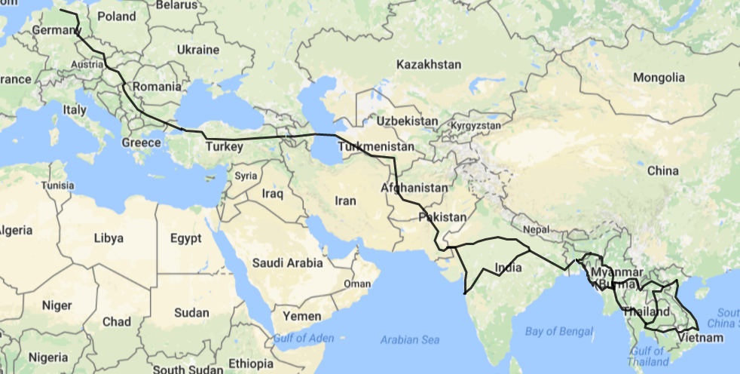
Source: https://www.mapdevelopers.com/

The so-called Silk Road between China and Europe arose in the first century BC and reached its apogee during T’ang China down to 756 AD, and flowered again briefly in the fifteenth century. By contrast, the Southern Corridor existed uninterrupted for 3,000 years down to the rise of the USSR after 1917. Thanks to the Uzbek scholar Edvard Rtveladze, we know that this route equally connected Central Asia—as well as the West-- with India, and that the “Great India Road” westward from the Indus Valley was extremely heavily travelled, with caravans of up to 4,000 camels being common. Large settlements of Indian traders existed throughout the route, and as far afield as Baku
and Constantinople, Bagan and Hanoi.

Trade between the Indian Sub-continent and Europe has burgeoned in the twenty-first century. The value of EU exports to India grew from $30.5 billion in 2006 to $41.78 billion in 2016, with engineering goods, gems and jewelry, other manufactured goods and chemicals ranking at the top. The value of EU imports from India also increased from $28.29 billion in 2006 to $43.52 billion in 2016, led by textiles and clothing, chemicals and engineering goods. As a result, down to 2016 the EU was India's number one trading partner (13.5% of India's overall trade with the world in 2015-16), well ahead of China (10.8%), USA (9.3%), UAE (7.7%) and Saudi Arabia (4.3%). India, in turn, was the EU's 9th trading partner in 2016.

These figures on East-West trade are dramatically enhanced when one takes into account other major economies that are directly on the route under discussion, namely, Turkey in the West and Pakistan and Bangladesh in the east. Thus, to speak only of Turkey’s trade with India, exports rose from under $1.58 billion in 2006 to over $5.78 billion by 2016, with imports rising from under $222 million in 2006 to $651.70 million in 2016. Similar gains in terms of percentage growth were registered in trade between Turkey and both Bangladesh and Pakistan.
The total value of EU/Turkey exports to the Indian Subcontinent was $37.5617 billion in 2006, which rose to $54.43662 billion in 2010. This fell back to $51.7816 in 2016 but presently appears to be rising once more. EU/Turkey imports from the Indian subcontinent have grown significantly faster than exports, with the value of EU/Turkey imports growing from $41.554 billion in 2006 to $63.90529 billion in 2010 and continuing to grow to $51.025 billion in 2016. This difference is reflected in the balance of trade growing from $-9.46867 billion in 2010 to $-23.7455 billion in 2016. Overall, trade between Europe/Turkey and India/Pakistan/Bangladesh is already among the most dynamic components of world trade as a whole. A dramatic increase of trade in both directions began around 2008 and continues unabated today, with a drop in Pakistan’s imports for several years after 2006 being the only exception.
To be sure, nearly all of these goods move today by ship. Indeed, certain large and heavy goods, such as massive machine tools and raw materials, should be transported on ships and always will be. Also, certain small and light weight items such as computer chips or portable electronic gear, should be sent by air freight and always will be. But there remains a significant part of the total that can be most efficiently moved between East and West by road or railroad. Many firms and freight forwarders in both Europe and India have estimated this figure for their own products. While their conclusions remain proprietary, it is clear that a third to two-fifths of the total measured by value could be moved most efficiently by road or railroad, provided these routes functions effectively. The reason for this is the time factor, in which land transport has a decisive advantage over sea-based transport.

This, then is the Southern Corridor.

Why Have We Not Heard More About This Southern Corridor?

By this point the reader may be asking why, if the Southern Corridor is so important, do we hear so little about it? There are three reasons for this.

First, unlike the fabled “Silk Road” to China, the Southern corridor up to now has had no name, let alone a highly evocative one. For centuries the route connecting the Indian Sub-continent with Central Asia was called “The Great India Road,” but this term fell into disuse with the rise of the USSR. Recently, the Government of Afghanistan has dubbed the route westward from Kabul to the Caucasus and Turkey the “Lapis Lazuli Corridor,” but this name applies to only part of the Southern Corridor and has yet to gain general usage. For the time being, no one has stepped forward with any name as bold as “The Silk Road,” which a German geographer, Baron Ferdinand von Richthofen, coined in 1877.

A second reason for the is scant attention that has been devoted to the Southern Corridor is that the routes linking Europe and China have been under active development since 1991, while the Southern Corridor is only now becoming a topic of general discussion. Indeed, no sooner did the Soviet Union collapse than both China and the European Union stepped forward with projects to forge land-based connections between their economies. ADB worked actively with China to develop the eastern side of this network while the EU and EBRD, through the Transport Corridor Europe-Caucasus-Central Asia (TRACECA) program, began developing the western side of the route through the Caucasus. By contrast, discussion of the Southern Corridor was nearly impossible during the period of Soviet invasion, civil war, and Taliban rule in Afghanistan, while seemingly insurmountable tensions between India and Pakistan further thwarted planning and even discussion of the project.

The third and most important reason for which the Southern Corridor has failed to become a major focus of discussion even among development experts is that all the major components that have been put in place to date have been funded and built by national governments rather than by international financial institutions or a single external power, as occurred with China’s funding of the Middle Corridor. Thus, since 2010 Turkey alone has invested at least $26.62 billion USD in the road, railroad, and pipelines that link its Mediterranean coast and Bosphorus with the Caspian, with Georgia and Azerbaijan now in the process of adding a further $2.5794 billion and $4.702 billion to build roads, railroads, and their new ports at Batumi and Alat . Turkmenistan, and Pakistan have invested at least $3.463 billion and $5.567 billion respectively in east-west corridor projects. The ADB, United States, Germany, Italy, the World Bank, and Saudi Arabia, amongst other partners, meanwhile have spent over $4 billion to build the Afghan Ring Road.

Each of these initiatives must be considered part of the single transport corridor connecting Europe and India. But for a variety of practical reasons it was easier for each state to proceed alone, albeit with de facto coordination, than to create and work through an overarching structure (and name!) to plan and coordinate the larger enterprise. ADB’s convening of Turkmenistan, Afghanistan, Pakistan, and India to develop the TAPI pipeline is thus a rare exception to the highly decentralized system of transport planning that has existed to now along the Southern Corridor. Amazingly, this decentralization has not led to fragmentation. But it has caused the larger program and the very substantial sums committed to its realization to be all but invisible, even to most specialists
- What are the Southern Corridor’s Prospects for Growth?

Notwithstanding the current global economic downturn and fragile recovery, long-term prospects for growth along the Southern Corridor are bright. Demographic realities detailed in this report, accelerating growth already discernible in the Indian sub-continent, and the maturing of the economic boom in China, which creates an opening for the South, all favor this prospect. The opening of efficient transport among them and with Europe and China will further stimulate Southern Corridor economies.

This positive trend is already clearly discernible. While acknowledging that all projections are by their nature speculative, let us here report that the IMF projects that the value of EU/Turkey exports to the Indian Subcontinent will rise from $51.789 billion in 2016 to $72.079 billion in 2021, a growth of nearly forty percent! The Value of imports from the Indian subcontinent is expected to rise from $75.527 billion in 2016 to $99.580 billion in 2021, or over thirty percent.
These data alone indicate the extent to which enormous new demands will be placed on transport facilities connecting Europe and India. Again, let us acknowledge that even if road and railroad land routes existed, they would probably carry only about a third of the total freight. But even if we accept this hypothetical estimate, it means that within five years at least $15 billion in goods annually would be likely to pass over land routes, if they exist.
But what about the longer term prospects? It is important to stress that the data just presented do not acknowledge or respond to what may be the single most important factor affecting the future of trade between the Indian Sub-continent and the West, namely the stunning growth of population expected in India, Pakistan, and Bangladesh over the coming two decades.
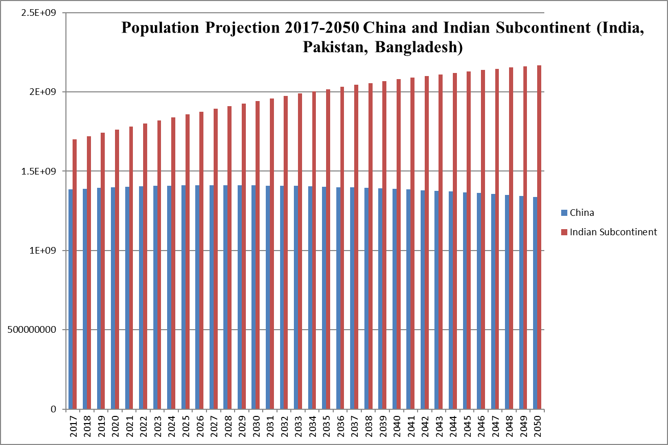
Source: World Bank http://databank.worldbank.org/data/reports.aspx?source=2&series=SP.POP.TOTL&country=CHN

In the year 2000 China’s working age population stood at 865 million people while India’s was 641 million. However, UN projections conclude that India will surpass China in population by 2025, and that China’s population by 2050 will be only approximately 799,014,054, a figure smaller than it is today. Since the demographic profiles of Pakistan and Bangladesh are similar to that of India, we can add their projected growth to the total for the Sub-continent. The result is a population that will be more than half again larger than China’s by mid-century.
But this represents only part of the profound change impending in the sub-continent. Due to various demographic factors (among which China’s one-child policy figures prominently), the number of working age adults as a percent of the total population will be far greater in India/Pakistan/Bangladesh than in China. Specifically, in 2050 the Subcontinent is projected to have a working age population of 1,462,946,249 while China will have a working age population of only 799,014,054, a difference of 663,932,195.
S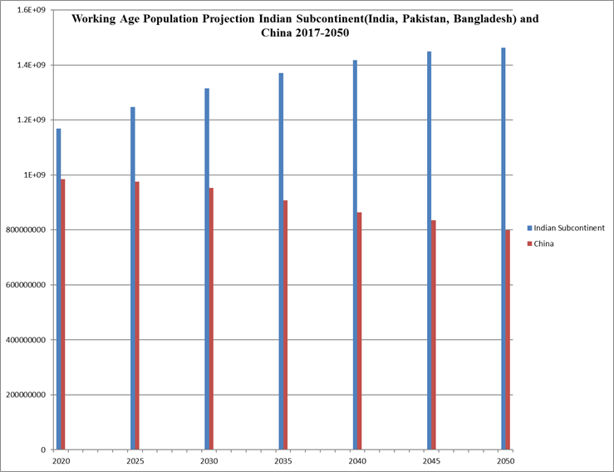
In short, there are solid reasons to conclude that prospects for growth in the use of the Southern Corridor are very strong, and are undergirded by long-term economic and demographic trends that can be clearly discerned in the present.
IV. What are the Missing Components of the Southern Corridor?

How far are we from having a functioning Southern Corridor that can transport goods between Europe and South Asia by road and railroad? Since 2001 the construction of hard infrastructure has proceeded apace across the region. Among the elements that
have already been completed or are near completions are:

- Road, railroad and pipelines from Baku to Istanbul via Georgia.
- New Caspian port at Alat, Azerbaijan.
- New Caspian port at Turkmenbashi, Turkmenistan.
- New road and railroad from Turkmenbashi to the Turkmenistan-Afghanistan border.
- Northern sector of Afghan Ring Road.
- Northern connector road between new port at Gwadar and Afghanistan.
- East-west grand trunk route across Pakistan.
- New railroad across the belt of India
- New competing ports at Gwadar Pakistan and Chabahar, Iran.
- Also relevant is India’s construction of roads and bridges in Bangladesh.

Other roads and bridges linking Central Asia and Afghanistan have been built by the United States, China, and Iran, with major support from ADB’s CAREC program.

This leaves several major hard infrastructure tasks yet to be accomplished. Among them are the following:

- Deepwater port in Georgia to facilitate transport westward from the Southern Corridor by sea.
- Road and railroad connectivity between Turkmen-Afghan border and Afghan ring road.
- Railroad along Afghan Ring Road to connect Turkmenistan and Pakistan.
- Either railroad crossing from Herat area to Kandahar or railroad dropping south to Kandahar from Kabul.
- Short road and rail link between Kandahar and Gwadar-Islamabad route.
Note: this requires only a very short passage through Baluchistan.
Develop road and railroad shore route across southern Pakistan and improve connectivity between Amritsar, India, and Lahore, Pakistan by the Wagah-Attari road and railroad.
- Complete road and railroad link from Afghanistan’s Ring Road to Iran’s new port at Chabahar.
- Application of new technologies to adjust to differing track gauges (already done at Caspian ports)

“Soft infrastructure” remains a serious challenge across the entire route from Istanbul to India and northward to Central Asia. Among tasks in this area are:

- Faster borders at the few key corridor crossings through reform and the application of new technologies.
- Adoption of agreements specifying the roles of national and international road and rail companies on international routes.
- Adoption of International Road Transport Union (IRU) standards across the region.
- Provision of regionally standardized insurance and storage for containers shipped by road or rail.
- Information systems regarding conditions and access, as well as border delays, for all rail and road routes.

It is easy to overstate the difficulty of improving soft infrastructure. In Afghanistan and Pakistan, for example, the focus must not be on all roads but simply on the two main corridor routes. Similarly, delays on the Wagah-Attari corridor can be easily resolved once the two economies develop the will to address them.
- Concept and Rationale for an ADB-CAREC Initiative to Open the Southern Corridor

A crucially important conclusion from the above analysis is that major elements of the Southern Corridor are already in place or are being constructed, thanks mainly to the efforts of individual countries along the route. Because of this, a major effort in behalf of the Southern Corridor as a whole need not centrally involve all the transit countries. All transit countries and commercial end users should, of course, be involved, but the main focus can and must be on the four key countries where impediments remain: Turkmenistan, Afghanistan, Pakistan and India.

It is therefore proposed that CAREC, in its next phase, focus on opening up the Southern Corridor and that it do so by concentrating above all on these four countries.
In doing this, CAREC should continue its existing efforts to connect Central Asian economies to the South. However, this should be directed towards opening existing routes to the Southern Corridor in such a way as to assure quick access by road and railroad eastward to Pakistan, India and beyond, and westward to Turkmenbashi and thence to the Caucasus, Turkey and eventually Europe. In short, the proposed next phase of CAREC will deepen and complete CAREC’s original mission.

A further aspect of this new phase will be to open up road and rail connections that will give Central Asian economies and Russia access to both new ports being built on the Arabian Sea, Chabahar in Iran and Gwadar in Pakistan. To date, the focus has been mainly on the route to Chabahar. But besides offering a shorter sea route to Southeast Asia, Gwadar, by offering competition to Chabahar, will help drive costs down for Central Asian and Afghan shippers. Moreover, Gwadar, if connected to Kandahar by road and rail as suggested above, will enrich Afghanistan’s restive Pashtun region, thus building stability throughout Afghanistan. Hence, both ports are important.

Nearly all of CAREC’s existing structures and relationships will be relevant to a new focus on the Southern Corridor and connections to it. However, CAREC will have to make several adjustments, among which are the following. First, it will have to add India to its structures. Second, it should be in closer touch with Southern Corridor countries that are beyond the four countries that will be CAREC’s main concern, specifically Bangladesh and Azerbaijan. It should also be in communication with the Southern Corridor’s future commercial “end users,” e.g., business interests and relevant officials in EU/Turkey and the Indian Sub-continent. Both of these can be accomplished by setting up periodic consultations.

Third, and in the same spirit of consulting “end users,” CAREC should open closer liaison with all the existing multi-lateral associations supporting the expansion of trade along part or all of the Southern Corridor. Among these are the South Asian Association for Regional Cooperation (SAARC), the Economic Cooperation Organization (ECO), the Shanghai Cooperation organization (SCO), the Heart of Asia-Istanbul Process, and the emerging intra-Central Asia consultative group.

ADB and the CAREC program are uniquely qualified to provide the lead in this multi-sided effort. For a quarter century ADB has been acknowledged to be the key multi-lateral driver and coordinator in the removal of barriers to trade and the promotion of regional economic growth, while CAREC has achieved recognized gains removing economic impediments among economies along the Middle Corridor. Most important, ADB is the only organization involved with this process that includes not only all the immediate regional countries but the major external powers, including China, Japan, and the United States. A further distinguishing asset is ADB’s high level of complementary with all other major international financial institutions, including World Bank, European Bank for Reconstruction and Development, Islamic Development Bank, and the China Development Bank.

- What are the Political Risks and Can They be Ameliorated?

One reason for which the Sothern Corridor has been so little discussed is that it appears
to be fraught with political risk throughout its entire length. Thus, an increasingly conservative and Sunni-Muslim oriented Turkey poses challenges to its partners in the Caucasus, Christian Georgia and secular but Shiite Azerbaijan. Azerbaijan and Turkmenistan are each building ports whose success depends on the other but their relations remain cool. The unlikely partners in the TAPI project continue to quarrel in unproductive ways, while Afghanistan and Pakistan appear to have once more sunk into contentiousness after attempting to patch up differences. Worst of all, India and Pakistan are once again on the brink of armed conflict over Kashmir and attempts by the new leadership of both countries to patch up differences have gone nowhere.

Under these circumstances, is it not imprudent and quixotic to promote a project that ultimately depends on cooperation? Is the political risk not so great as to kill any hopes for success?

It is not our intention to minimize any of the issues listed above. However, it is important to note that in every case mentioned above there also exist important forces and factors that lead to cooperation. Moreover, the very process of identifying the Southern Corridor as a potential source of benefit to individual countries and to the region will help balance consciousness of the risk with perceptions of the opportunities, and of the economic costs of inaction.

Critics or potential critics of this Corridor project will not go unchallenged. Indeed, there are powerful interests in every country that already support the Southern Corridor, or will do so if ADB were to champion it. The Erdogan government in Turkey already strongly supports it and has invested heavily in key infrastructure elements. Georgia, Azerbaijan, and Turkmenistan all see their future role as part of an east-west “land Suez” and consider it vital to the protection of their economies and sovereignty itself. In spite of differences, Turkey, Georgia and Azerbaijan see each other as valued partners in a shared enterprise, while Turkmenistan’s relations with Azerbaijan have expanded steadily in recent years, in spite of on-going disagreements over the delineation of Caspian energy deposits. Afghanistan’s two post-Taliban presidents, Hamid Karzai and Ashraf Ghani, disagree on much but both have strongly supported a major east-west transport corridor through their country and have been eager to enlist Pakistan, notwithstanding their differences with Islamabad. To date these have been largely thwarted, however.

The two most intransigent political risks along the entire route are the Afghanistan-Pakistan border and the India-Pakistan border. In both cases, there are forces in each country that find that a spirit of enmity between the two neighbors serves their interests better than collaboration. Pessimists abound, and in the case of India-Pakistan relations even predict a worsening of relations after the impending 2018 elections in Pakistan and 2019 elections in India.

Yet all three countries are quite capable of separating their interests from their passions. Why else would Pakistan have championed the TAPI project over two decades, and agreed to bring India into it in order to increase its chances of success? Why else would India remain committed to a project that depends entirely on Pakistan’s cooperation? The government of Pakistan has at times thwarted trade across its border with Afghanistan yet new trucking firms based in Islamabad are among the most active shippers throughout Afghanistan, Central Asia, and clear to the Caucasus. Many were founded by former officers in the Pakistani army.

Registered trade between India and Pakistan is a paltry $2.5 billion a year and intra-regional trade within the Sub-continent is a mere 5% of all of the three countries’ officially registered trade---barely a fifth of the figure for Southeast Asia. But as much as twice more trade passes between India and Pakistan that is unregistered. Far from being illicit goods, this consists of household appliances and foodstuffs that would be registered if a normal border regimen existed. The fact that both Indians and Pakistanis resort to the inconvenience and expense of trading through Dubai reflects the existence of powerful and growing business interests favoring improved commercial relations between the two states.

As manufacturing expands in both India and Pakistan, and as both economies become increasingly dependent upon that sector, the opportunity cost of closed borders becomes increasingly apparent. Indeed, there is no more powerful force advocating the reduction of barriers to trans-border trade between India, Pakistan, and Afghanistan than the growing tendency within businesses and in governments to calculate the opportunity cost of not doing so. There is no reason to think that this will reduce tensions arising from disagreements between Afghanistan and Pakistan over the Duran line or between Pakistan and India over Kashmir. But the prospects of profits have already led commercial and political interests in all three countries to expand their cross border trade with one another, even as political and religious enmities continue. And all this has occurred without so much as a mention of long-distance transport and trade. If the continental dimension of eased cross-border activity were known to businesses and governments, it is bound to change the calculus in favor of more trade and more engagement.

Similarly, Central Asians do not appreciate the opportunity cost of their not being able to utilize the Southern Corridor to both Europe and to the Indian sub-continent and Southeast Asia. An initial task of the proposed program would be to encourage all participating countries to estimate the savings and gains that access to major markets through the Southern Corridor would bring, and the annual cost of not having such access.

Finally, if any party proves intransigent, there remains the sea routes from Mumbai to Chabahar and from Southeast Asian ports to Gwadar. Both ports would be part of the study, so CAREC would be able to concentrate both of sea and land routes for this key section. Indeed, by exploring both, it will be possible to determine any differences in cost between water and land routes and the degree to which each is likely to be utilized. Because this alternative will also be under study, no party would have grounds for objecting that CAREC also analyzed and fostered land routes for this section as well. Good planning requires that all options be explored. In this instance it requires the full study of land routes between India and Afghanistan, their cost and likely usage under various conditions. Whether or not this assumes a post-conflict situation is a question best left to the politicians.

- How Can ADB Advance This Project?

A redirection of CAREC’s focus to the Southern Corridor and associated links to enable Central Asians to access East-West trade through that route is entirely compatible with CAREC’s existing structures and methods. CAREC’s monitoring of current developments need only be shifted slightly to serve the new direction, and the same is true for its network of think-tanks and official meetings. The main structural change would be the inclusion of India, engagement with SAARC, and regular interaction with the market based “end users” of the new corridor in Europe/Turkey and the Indian Sub-continent.

This last point is of great importance, for the Southern Corridor project cannot succeed without it being conceived from the outset as a geographical whole, and without consultation with those in the private sector who will actually use it. Even with this shift, however, the redirection of CAREC will require evolution, not revolution.

It is important to stress that the goals and methods of CAREC would continue to be driven solely by economic considerations. In this respect it might be contrasted with most, if not all, of the existing regional consultative structures, which tend to be driven significantly by politics.

An important challenge will be to achieve appropriate forms of coordination with China’s One Belt One Road (OBOR) initiative and the EU’s TRACECA. This can be achieved by various means. However, it would be premature at this point to attempt to specify the best mode of coordination between these two continent-spanning projects. Suffice it to say that such coordination will be important, and should be achieved through processes that are consistent with the ADB’s overall modus operandi.

Far the most important determinate of ADB’s success in advancing the Southern Corridor project will be the manner in which it advances and explains the concept. As we have noted several times above, few leaders of the affected countries have fully grasped the importance of the economic rise of India, Pakistan, and Bangladesh, and its potential significance to continental trade extending from Hamburg to Thailand. The first challenge ADB and CAREC will face, then, will be educational: to get transit countries and private sector end users to engage with the prospect of this fundamental development and to translate that engagement into concrete actions.

Given the centrality of this task, it is no exaggeration to say that ADB’s chief contribution to the future success of the Southern Corridor will be its convening power. No less than its money and investments, the active use of ADB’s convening power will be essential to the success of the project as a whole. The active use of this power, and the focus of attention on economic benefits arising from a functioning Southern Corridor, will do more than anything else to dissolve the toxic zero-sum thinking that has delayed progress to date.

This is no abstraction. In order for all the diverse parties to come together to the extent this economic initiative requires, it will be essential for them to calculate soberly the opportunity cost of not doing so. This does not mean laying aside points of contention and conflict. Rather, it means embracing economic advancement as a process that can go forward even as sharp differences remain in other areas.

- What are the Chances that a Focus on the Southern Corridor Will Succeed?

Any assessment of the political risk to ADB arising from its promotion of the Southern Corridor will be affected by the likelihood of its success in that endeavor. In considering this crucial question it is important to note at the outset that ADB/CAREC will not be beginning de novo. Far more than China’s New Silk Road, all countries along the Southern Corridor have on their own launched important infrastructure projects that feed directly into the proposed continental network. Without minimizing the scale of infrastructure yet to be constructed, this means that ADB can focus on the practical economics of the Southern Corridor as they pertain to each country along the route. Moreover, it makes possible an early focus on market-based commercial “end users” in the East and West, whose engagement with the project will determine its long-term viability and the scale of the benefits it bestows on to transit countries.
Can ADB reduce the political risks entailed? Skeptics rightly point out that neither CAREC, the Heart of Asia process, the Economic Cooperation Organization (ECO), nor other international collaborations have ameliorated the most significant regional tensions. Why, then, should we expect an ADB focus on the Southern Corridor to do what other initiatives have failed to do?

It is crucially important to note that none of the existing international efforts has explicitly and emphatically been grounded in a rational and convincing vision of emerging continental trade along the Southern Corridor. Whereas the underlying logic and prospects of the China-Europe connection have swept away nearly all doubts on the validity of the New Silk Road or Middle Corridor, no one, let alone a major international financial institution, has made the case for the Southern Corridor. With no vision of the economic benefits that could arise from the Southern Corridor, existing political risks remain unchallenged and unresolved. But if ADB were to calculate and announce the likely scale of continental and regional trade along that route, and then proceed to back efforts to remove impediments to its realization, it would dramatically affect the calculations of all countries involved.

It cannot be ADB’s mission to engage in the politics that underlie regional tensions. However, with its highly professional focus on economics, it is well positioned to point out the benefits of the proposed continental route and the opportunity costs that will be incurred if it is not developed. The key to success for such an effort will be to identify and proclaim to each country along the route the opportunity cost of non-participation. Whether and how participation affects on-going strains in the political sphere is up to each country to decide on its own.

- What are Opportunity Costs of Inaction?
In economics, as in physics, there is no rigorous method for measuring the consequences of non-action. However, it is safe to assume that if the ADB and CAREC were to hold back from supporting the Southern Corridor, they would strengthen the likelihood that the status quo would continue in key member countries or that current economic trends there would intensify. One can hypothesize this happening in four areas.

First, the continued economic stagnation and isolation of Afghanistan would engender social and political instability there for the foreseeable future. This will strengthen the Taliban and further open the country to foreign extremist fleeing Iraq and Syria.

Second, this will perpetuate the continued isolation of CAREC members in Central Asia from nearby and traditional trading partners in Afghanistan, Pakistan and India. Not only will it guarantee continued low levels of investment from the Indian Sub-Continent and Southeast Asia but it will prevent them from marketing their products (cotton, vegetables) and manufactured goods to South and Southeast Asia. In short, it will prevent CAREC from achieving several of its key goals.
Third, inaction will reduce the likelihood that economic interaction will promote the reduction of tensions between Pakistan and India. At the same time, the growing imbalance between China’s increasing access to land routes to Europe and India’s total dependence on sea lanes is bound to foster tensions between these great powers in the Indian Ocean and specifically in the Bay of Bengal and Arabian Sea.

Finally, inaction on the Southern Corridor will marginalize the Asia Development Bank and reduce it to the role of spectator or minor participant in important regional economic developments promoted by others. As to CAREC, it will but a firm cap and end point on the further development of what has otherwise been a visionary and successful program.

Assisting in the research for this essay was Mr. Berke Gursoy, an intern at the American Foreign Policy Council. I gratefully acknowledge the close attention and tenacity he lavished on the project.
Edvard Rtveladze, Velikaia Indiisakaia Doroga, St. Petersburg, 2011.
IMF/http://data.imf.org/regular.aspx?key=61013712
http://ec.europa.eu/trade/policy/countries-and-regions/countries/india/; also http://data.imf.org/regular.aspx?key=61013712
http://www.mfa.gov.tr/turkey_s-commercial-and-economic-relations-with-india.en.mfa
To be sure, Pakistan’s imports from Europe/Turkey plummeted after 2006 but they have since recovered.
http://data.imf.org/regular.aspx?key=61013712
Turkey’s investment value takes into account its major East-West focused transport projects undertaken since 2010, it does not take into account planned future projects. BTK railroad, Marmary Tunnel, Eurasia Tunnel Ankara-Istanbul High Speed Rail, Yavuz Sultan Selim Bridge, Canakkale 1915 Bridge, Ilgaz Tunnel, Great Istanbul Tunnel
Georgia: Batumi Port, BTK Rail Line
Azerbaijan: CAREC Report: http://www.carecprogram.org/uploads/events/2017/12-16th-TSCC-Meeting/2017-16th-TSCC-TSPR.pdf, BTK Rail Line
Pakistan: http://www.carecprogram.org/uploads/events/2017/12-16th-TSCC-Meeting/2017-16th-TSCC-TSPR.pdf Turkmenistan: http://www.carecprogram.org/uploads/events/2017/12-16th-TSCC-Meeting/2017-16th-TSCC-TSPR.pdf and Turkmenbashi International Seaport http://tdh.gov.tm/news/en/articles.aspx&article4263&cat29
List of Partners: https://www.afghanistan-analysts.org/going-in-circles-the-never-ending-story-of-afghanistans-unfinished-ring-road/ Investment Value: https://www.sigar.mil/pdf/special projects/SIGAR-14-64-SP.pdf
https://www.imf.org/external/pubs/ft/weo/2017/01/weodata/index.aspx
For data on total population growth see http://databank.worldbank.org/data/reports.aspx?source=2&series=SP.POP.TOTL&country=CHN For data on working age population as a share of the total see United Nations, Department of Economic and Social Affairs, Population Division (2017) https://esa.un.org/unpd/wpp/DataQuery/
For data on total population growth see http://databank.worldbank.org/data/reports.aspx?source=2&series=SP.POP.TOTL&country=CHN For data on working age population as a share of the total see United Nations, Department of Economic and Social Affairs, Population Division (2017) https://esa.un.org/unpd/wpp/DataQuery/
Note that the east-west routes through Iran from Chabahar or Herat to Turkey are not included in this report. Iran has received help from both China and Russia for the construction of this corridor, while India has invested heavily in Chabahar. However, Iran is not a member of DB/CAREC and cannot participate in the proposed program. Moreover, construction of these routes lags behind the development of infrastructure for transporting goods by road and rail, as well as gas and oil, through the Caucasus. However, the link from Chabahar to the Afghan Ring Road is important and is discussed below.
http://www.icrier.org/pdf/Working_Paper_327.pdf

